Dr. Rima Kumari: Date: 21/09/2020
Online class and e- content for M.Sc. III semester students
Date and Time | Online class medium | E. content topic
21/09/2020  12:30 p.m to 1.00 p.m | Via Google meet  Link: Meeting URL: https://meet.google.com/iqc-gfzx-ryq | Animal and Plant Cells  ENDOPLASMIC RETICULUM (ER)
1.4.3 Animal and Plant Cells
The internal structural organisation and information related with hereditary characters and metabolic pathways are similar in all eucaryotic cells whether they are of plants, fungi, animals or protists. On the other hand plant and animal cells differ in some respects. Cell wall in plant cells is unique. It provides mechanical support and protection. Besides, the cell wall helps to balance osmotic pressure of the cell with the surrounding medium. It consists of a network of cellulose and a gel-like matrix. Plant cells also contain pigment containing organelles called plastids such as chloroplasts (green colour), chromoplasts (red colour) and leucoplasts (no colour). Chloroplasts help the plants to synthesise their own food in presence of sunlight (autotrophs). Presence of large vacuoles is another important feature which distinguishes the plant cells from the animal cells. Endoplasmic reticulum (ER) plays a significant role in the formation of vacuoles. Glyoxysomes, the microbodies found in some plant cells, are involved in lipid metabolism. Golgi complexes found in plant cells are called as dictyosomes. The animal cells, often contain flagella and cilia for movement, and centrioles for cell division. On the other hand, these-organelles are generally absent in plant cells. The difference between plant and animal cells are listed in the Table and illustrated in the Fig. for your ready comparison.

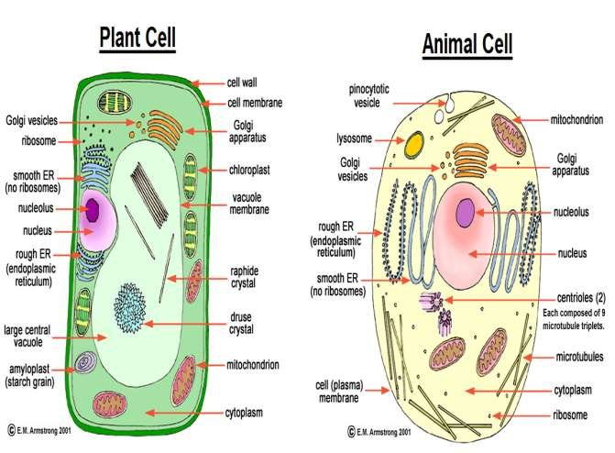

3.2 ENDOPLASMIC RETICULUM (ER)
Eucaryotic celIs have two major compamnents- nucleus and cytoplasm. Cytoplasm was known to have no structure until the discovery of electron micrsscope. That cytoplasm is permeated by a membranous network called endoplasmic reticulum (ER), was revealed only after the introduction of electron microscope. Endoplasmic reticulum is a three dimensional network of membrane channels which constitutes more than half of the total membrane of the cell, ER is a highly folded and convoluted structure and forms a single continuous sheet enclosing one continuous sac. The interior of the sac is called "cysternal space" or "ER lumen". This is separated from the cytoplasm also called cytosol by a single membrane which mediates the communication between these two compartments. ER provides the cell with a compartment for storage of substances to be kept separate from cytosol. In addition, it has a key role in the biosynthesis of macromolecules.
ER is a double membranous organelle which consists of interconnecting flattened sacs called cisternae or interconnected tubules or vesicles. Cisternae are temporary storage sites for nutrients.

- Three physical forms of ER, lamellar, vesicular and tubular. The lamellar type of ER is in the form of flattened membrane sacks, the vesicular type of ER is in the form of vesicles, and tubular type of ER is in the form of tubules.
- Endoplasmic reticulum shows the continuity of ER types that exists between adjacent membranes and cisternae of both rough and smooth ER. Rough ER membranes are characteristically sheet like, whereas smooth ER membranes are characteristically tubular.

Rough and Smooth Endoplasmic Reticulum (RER and SER) : ER is differentiated into two regions, granular or rough endoplasmic reticulum (RER) and agranular or smooth endoplasmic reticulum (SER). These twb regions also differ considerably in shape:

Rough ER is organised in stacks of flattened sacs called cisternae and smooth ER consists of a mesh work of fine tubules (Fig. 3.1 b). In RER, the outer surface in the cytoplasmic site of the membrane is studded with small particles called ribosomes whereas in SER, the ribosomes are absent. Ribosomes are the sites of protein synthesis. Thus, it is evident that RER is more abundant in cells which are actively engaged in synthesis and export of proteins, for example, pancreatic cells and plasma cells.

SER is found in those cells which are specialised in lipid metabolism and which secrete steroids such as the cells of adrenal cortex, the testes and ovary. Smooth ER is also present in liver cells where it helps in detoxification of drugs and poisons.

ER (both RER and SER) performs many mechanical functions of the cell by providing mechanical support. Large surface area of ER helps in the exchange of materials across the membrane by diffusion and active transport. ER may act as a kind of circulatory system for the distribution of various substances in the cell.

