Dr. Rima Kumari: Date: 28/07/2020
Online class and e- content for BSc IInd year students

Date and Time | Online class medium | E. content topic
28/07/2020  01:00 p.m to 1.50 p.m | Via Google meet  Link: Meeting URL: https://meet.google.com/zcx-couc-ksw | Mendel’s law of Inheritance

BOTANY (HONS.) PAPER III Unit IV

Mendel’s Principles and its modifications
Genetics
Genetics is a branch of biology concerned with the study of genes, genetic variation, and study of hereditary characters (genetic characters passed on from generation to generation) in organisms.
Gregor Johann Mendel
Gregor Johann Mendel (1822-1884) is called as Father of Genetics. Gregor Mendel, a scientist and Augustinian friar working in the 19th century, was the first to study genetics scientifically. Gregor Johann Mendel (1822-1884) is called as Father of Genetics. He was born in 1822 to a family of poor fathers an area that is now part of Czech Republic.
Earlier in 1847, Mendel worked as priest in Augustinian Monastery at Brunn and was ordained. But he has great interest in plant hybridization. In 1849 Mendel join the University of Vienna for training in physics, mathematics and the natural sciences as temporary teacher. In 1854 Mendel again took up the profession of a teacher and continued there for fourteen years. During this long period he conducted his famous garden pea experiments in the monastery garden which develops the concept of
Mendel experimented on garden pea (Pisum sativum) in the monastery garden for about nine years (1856-1864) and published his results in a less known journal-The Annual proceedings of the Natural History Society of Brunn in 1865.
Mendel’s Experiments:
Mendel performed cross breeding experiments on garden pea (Pisum sativum). He examined the inheritance behaviour of seven pairs of contrasting characters in this plant but considered only one pair at once a time. For example at a time, he crossed two pea plants having contrasting characters of height (tall and dwarf pea plants) by artificial pollination and obtained the result of hybrids (F1 generation). The resulting hybrid plants were then crossed with each other. He obtained the data from these crosses and analysed the results carefully (F2 generation).
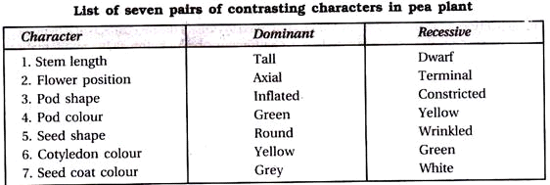
Mendel selected garden pea as his experimental material due to the following advantages:
1. Pea plant is easy to grow and interbreed.
2. Peas reproduce and grow to maturity in a season (an annual plant). Because of short life cycle several generations can be produced within a short period.
3. The pea plants have a number of contrasting characters.
4. The flowers are bisexual containing both male and female parts. They are self-fertilising in nature.
5. Because of easy self-fertilization, it is easy to get pure lines for several generations.
6. It is easy to hybridize because pollen from one plant can be introduced into the stigma of another plant by removing anthers.
7. It produces fertile hybrids. This enabled Mendel to continue his experiments for generations
For his experiment Mendel initially selected pea plants with contrasting characters such as tall and dwarf. These plants were pure or true breeding for particular character of height. For example, to get a pure line for tallness of the stem, he self-fertilized a tall pea plant for several generations till the resulted offspring always produced only tall plants (P1). Likewise, he got genetically pure variety of dwarf pea plants by adopting the same technique (P2). Since garden pea is self-fertilizing, the panthers have to be removed before maturity. This operation of removal of anthers is called emasculation. The stigma is protected against any foreign pollen by bag cover. For each of the seven pairs of characters, plants with one alternative trait were used as female and those with the other alternative as male. Reciprocal crosses were also made. The population obtained as a result of crossing parent plants having contrasting characters is called the first filial generation or F₁ (filial means progeny). The F₁ plants when self-fertilised to produce second filial generation plants or F₂ plants. Similarly F₃, F₄ etc. can be produced.
Mendelian Laws/ Principles of Genetics/ Heredity:
1. Law of Dominance:
When a pair of contrasting characters (or allelomorphic characters or alleles) are present together, only one of them expresses itself and the other remains suppressed of hidden The character which is expressed (or is visible) is called as dominant and the character which remains hidden is termed as recessive.
2. Law of Segregation or Purity of Gametes:
The allelic factors or genes present together in the hybrids segregate (separate) from one another in gamete formation in randomized way and are placed in different gametes in the next generation.
3
. Law of Independent Assortment:
When two or more pairs of contrasting characters are taken into consideration in a cross, each factor, assort or place itself independently of the other (lining its passages from on; generation to the other.
Mendelian Terminology:
1. Genotype and Phenotype:
Genotype refers to the genetic makeup or genetic constitution of an organism. Phenotype indicates the external appearance of an organism. TT and Tt are phenotypically same tall plants but genotypically different as one is pure tall (TT) and other is hybrid tall (Tt).
2. Homozygous and Heterozygous:
Every organism possesses two genes (alleles) for every character. If in an organism the two genes (alleles) for a particular character are identical (for example TT or tt), it is said to be pure or homozygous (homo = the same, zygo = a pair). If the organism possesses contrasting genes (alleles) for a particular character (for example Tt), it is said to be impure or heterozygous (hetero = different, zygo = a pair).
3. Dominant and Recessive:
A heterozygote possesses two contrasting genes (say ‘Tt’), but only one of the two is able to express itself (tallness), while the other remains hidden (dwarfness). The gene which is able to express in 1, hybrid (here ‘T’) is known as dominant gene, while the other gene which is unable to express itself (here’t’) in the presence of dominant gene is called as recessive gene.
4. Allele or Allelomorph:
Mendel stated that two genes (factors) representing two alternatives of a character are present on two separate chromosomes of a homologous pair but at the same loci or position. For example, in a gene pair Tt, T is present on one chromosome and t on the other chromosome but at the same locus or position. Each of them is called an allel to the other (T is an allel to t and vice versa).
5. Gene:
It is the unit of inheritance representing a particular characteristic. It is located in the chromosome and formed of a DNA segment. It was termed as factor or determiner.
6. Hybrid:
A progeny resulting from a cross between two parents differing at least in a single character.
7. Reciprocal Cross:
It is the second cross involving same genotypes as first cross but the sexes are reversed. If the first cross is Tall (female) x Dwarf (male), then the second or reciprocal cross will be Tall (male) x Dwarf (female).
P1 (tall male plant) x P2 (dwarf female plant) F1 progeny (tall)
P1 (tall female plant) x P2 (dwarf male plant) F1 progeny (tall)
As tall character trait/ gene are dominant
The reasons for Mendel’s success are as follows:
1. Mendel studied the inheritance of one character at a time while previous researchers considered the organism all characteristics as a whole.
2. He carried out his experiments upto F2 and F3 generations.
3. His knowledge in statistics helped him to maintain accurate records of all the experiments of findings and analysed them carefully.
4 He grew pure lines in separate plots and conducted experiments by crossing two plants from pure strains
5 All this genetical experiments were conducted with utmost care and meticulous planning

Variations in Mendel’s rules in case of single genes
Some of the variations on Mendel’s rules involve single genes. These include:
Multiple alleles. Mendel studied just two alleles of his pea genes, but real populations often have multiple alleles of a given gene.
Incomplete dominance. Mendel’s results were groundbreaking partly because studies shows the contradicted results in some cases. Two alleles may produce an intermediate phenotype when both are present, rather than one fully determining the phenotype. The phenotype of a heterozygous organism can be a blend between the phenotypes of its homozygous parents.
For example, in the snapdragon, Antirrhinum majus, a cross between a homozygous white-flowered plant (C^{W}C^{W}) and a homozygous red-flowered plant (C^{R}C^{R}) will produce offspring with pink flowers (CRCW). This type of relationship between alleles, with a heterozygote phenotype intermediate between the two homozygote phenotypes, is called incomplete dominance.
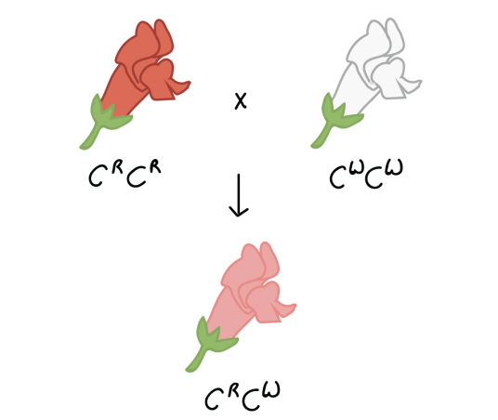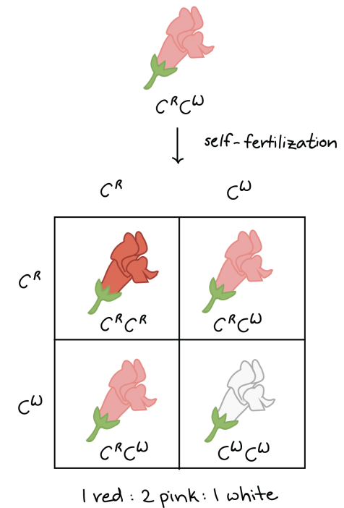

- Codominance. Both alleles may be simultaneously expressed when both are present, rather than one fully determining the phenotype.

- Pleiotropy. Some genes affect many different characteristics, not just a single characteristic.
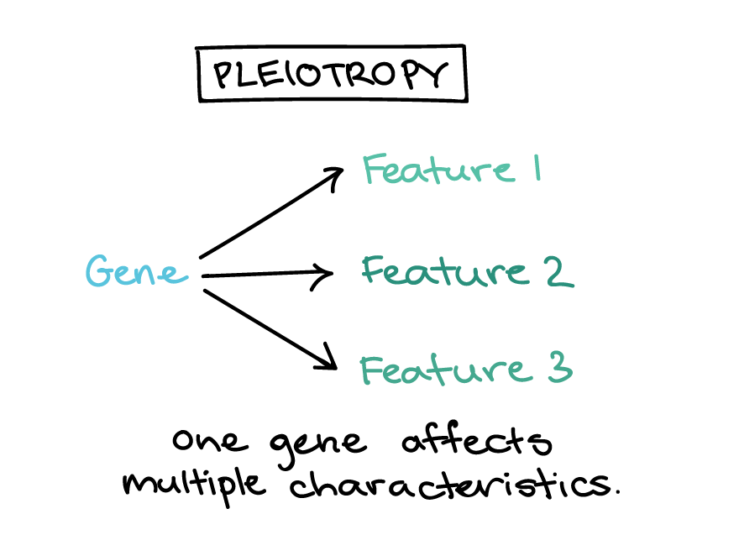
- Lethal alleles. Some genes have alleles that prevent survival when homozygous or heterozygous.
- Sex linkage. Genes carried on sex chromosomes, such as the X chromosome of humans, show different inheritance patterns than genes on autosomal (non-sex) chromosomes.

