Constraints
The limitations on the motion of a system are called constraints .The motion is said to be constrained motion . Constraints are always related to forces which restrict the motion of the system.These forces are called forces of constraint.

Holonomic and Nonholonomic Constraints

The nomenclature ‘holonomic’ constraints comes from the word ‘holos’which means ‘integer’ in Greek and ‘whole ‘ or intergrable’ in Latin languages .

A system is said to be non-holonomic .If it corresponds to non-integrable differential equations of constrains .

1

Degrees of freedom and constraints

Consider a system S with N particles, Pr (r=1,...,N), and their positions vector xr in some reference frame A. The 3N components specify the configuration of the system, S.

The configuration space is defined as:
T

ℵ= ⎨X
X ∈ R^{3N} , X = [x
.a , x .a
, x .a
,😐x
.a , x
.a , x
.a ] ⎬

The 3N scalar numbers are called configuration space variables or coordinates for the system.
1
1
1
2
1
3
N
1
N
2
N
3

The trajectories of the system in the configuration space are always continuous.

2

A System of Two Particles on a Line

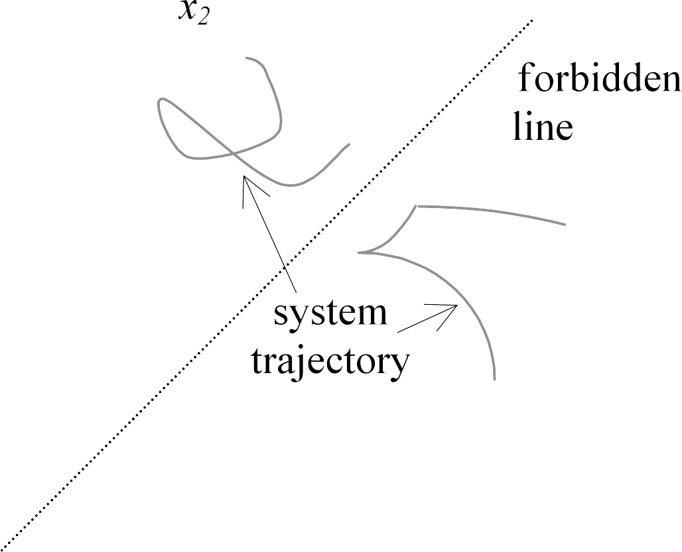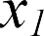

3

Holonomic Constraints

Constraints on the position (configuration) of a system of particles are called holonomic constraints.

- Constraints in which time explicitly enters into the constraint equation are called rheonomic.

- Constraints in which time is not explicitly present are called scleronomic.

- Particle is constrained to lie on a plane:
A x₁ + B x₂ + C x₃ + D = 0

- A particle suspended from a taut string in three dimensional space.
(x1 – a)2 +(x2 – b)2 +(x3 – c)2 – r2 = 0

- A particle on spinning platter (carousel)
x1 = a cos(ωt + φ); x2 = a sin(ωt + φ)

  - A particle constrained to move on a sphere in three-dimensional space whose radius changes with time t.
x1 dx1 + x2 dx2 + x3 dx3 - c2 dt = 0
4

Holonomic Constraint

x3
Configuration space
f(x1, x2, x3)=0
x2
x1
5

Scleronomic, holonomic
Rheonomic, holonomic

t

f(x1, x2)=0 f(x1, x2, t)=0

f(x1, x2 , t4)=0

f(x1, x2 , t3)=0

Configuration space
x2
f(x₁, x₂)=0
x1 x1

f(x
f(x1, x2

, x , t
, t2)=0
x2

)=0

1 2 1

6

Definition 1

Nonholonomic Constraints
- A particle constrained to move on a
x

- All constraints that are not holonomic

Definition 2
- Constraints that constrain the velocities of particles but not their positions

We will use the second definition.
circle in three-dimensional space
whose radius changes with time t. x1 dx1 + x2 dx2 + x3 dx3 - c2 dt = 0
  - The knife-edge constraint
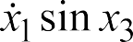
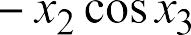√

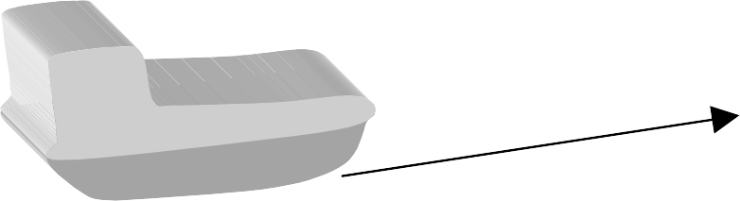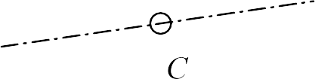 7

Aside: Inequality Constraints

Holonomic or non holonomic?
- Inequalities do not constrain the position in the same way as equality constraints do.
- Rosenberg classifies inequalities as nonholonomic constraints.
- We will classify equality constraints into holonomic equality constraints and non holonomic equality constraints and treat inequality constraints separately

Inequalities in mechanics lead to complementarity constraints!

8

Complementarity Constraints

separation, δ
normal force, λ

δ = 0, λ > 0
δ > 0, λ = 0
δ < 0

More generally,
0 ≤ δ ⊥ λ ≥ 0

9

Examples of Velocity Constraints

Example 1

Are these configuration constraints?

A particle moving in a horizontal plane (call it the x-y plane) is steered in such a way that the slope of the trajectory is proportional to the time elapsed from t=0.
z
Example 2: Disk rolling on plane
a₁
b
e₂
3
C
C*
q₄
q₁
q₃
b₁
P
e₃
e₁

Rolling constraint at P
a₃
q₂

a₂
b₂
y

x
q₅

10

When is a constraint on the motion nonholonomic?

Velocity constraint

We should be familiar with this question in the 3 dimensional case

Or constraint on instantaneous motion
P dx + Q dy + Rdz =0
v
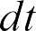

Pfaffian Form

Question
Can the above equation can be reduced to the form:
f(x1, x2, ..., xn-1, t) = 0

Can we construct a surface in 3-D whose normal at every point is given by v?

11

When is a scleronomic constraint on motion in a three-dimensional configuration space nonholonomic?

Velocity constraint

Or constraint in the Pfaffian form
P dx + Q dy + Rdz =0 (1)

Question
Can the above equation can be reduced to the form:
f(x, y, z)=0
Or,
Can we at least say when the differential form (1) an exact differential?
df = P dx + Q dy + Rdz
- A sufficient condition for (1) to be integrable is that the differential form is an exact differential.


- If it is an exact differential, there must exist a function f, such that

- The necessary and sufficient conditions for this to be true is that the first partial derivatives of P, Q, and R with respect to x, y, and z exist, and


Recall result from Stokes Theorem!

12

Exactness and independent of path


If v is continuous and has continuous first partials in a domain D, and the line integral

is independent of path C in D (that is, v.dr is exact) then



(2)
C’’
C’
C


But (2) is only a sufficient condition for
(1) to be integrable.

13

Necessary and sufficient condition for a motion constraint in 3-D space to be holonomic

Can the constraint in the Pfaffian form
P dx + Q dy + Rdz =0 (1) be reduced to the form:
f(x, y, z)=0

For the constraint to be integrable, it is necessary and sufficient that there exist an integrating factor α(x, y, z), such that,
- If (3) is an exact differential, there must exist a function g, such that

  - The necessary and sufficient conditions for this to be true is that the first partial derivatives of P, Q, and R with respect to x, y, and z exist, and

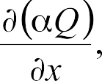
αP dx + αQ dy + αRdz =0 (3) be an exact differential.

14



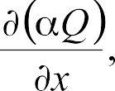
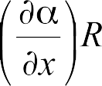
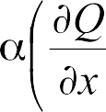
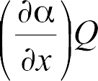
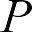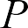Does there exist α such that:

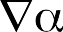
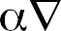

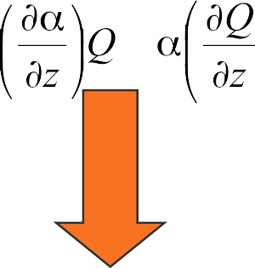Necessary and sufficient condition for
(2) to be holonomic, provided v is a well-behaved vector field and
15

1. sin x3 dx1 - cos x3 dx2 = 0

Examples

2. 2x2x3 dx1 + x1x3 dx2 + x1x2 dx3 = 0

x1 (2x2x3 dx1 + x1x3 dx2 + x1x2 dx3) = 0

3.

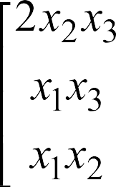
d((x1)2 x2 x3) = 0

 University of Pennsylvania 16

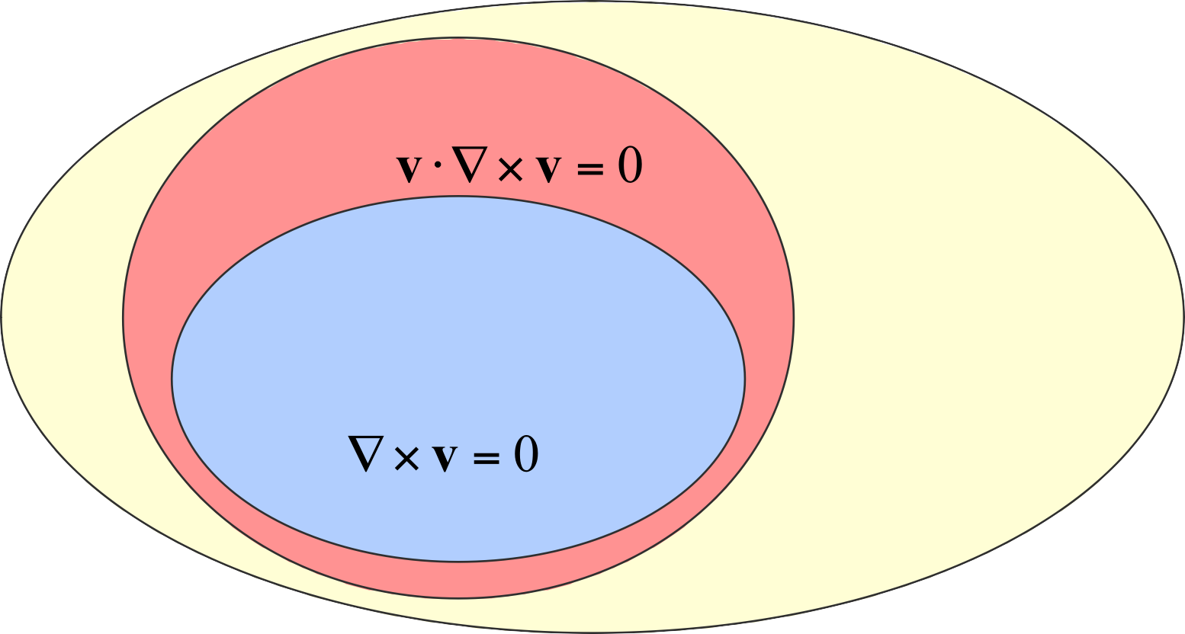Nonholonomic constraints in 3-D
Other nonholonomic constraints

Holonomic
Nonholonomic

Holonomic
P dx + Q dy + Rdz =0

17

Extension to 2-D rheonomic constraints

Compare

Can the constraint of the form
P dx + Q dy + Rdz =0 be reduced to the form:
f(x, y, z)=0

Can the constraint of the form
P dx + Q dy + Rdt =0 be reduced to the form:
f(x, y, t)=0


Necessary and sufficient condition is the same if you replace z with t

18

dx2 – x3 dx1 = 0 and
dx3 – x1 dx2 = 0

Multiple Constraints

Are the constraint equations non holonomic?

Individually: YES!

Together:

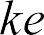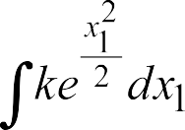dx3 – x1 dx2 = dx3 – x1 (x3 dx1) = 0

19

Frobenius Theorem: Generalization to n dimensions
n dimensional configuration space
v
w
u
m independent constraints (i=1,..., m)

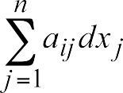

The necessary and sufficient condition for the existence of m independent equations of the form:
fi(x1, x2, ..., xn) = 0, i=1,..., m.
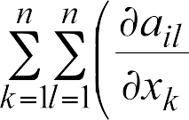
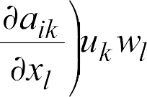
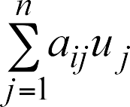is that the following equations be satisfied:

where uk and wl are components of any two n vectors that lie in the null space of the mxn coefficient matrix A = [aij]:
20

Generalized Coordinates and Number of Degrees of Freedom

Number of degrees of freedom of a holonomic system in any reference frame
- the minimum number of variables to completely specify the position of every particle in the system in the chosen reference

The variables are called generalized coordinates
No. of degrees of freedom

= No. of variables required to describe the system
- No. of independent configuration constraints

There can be no holonomic constraint equations that constrain* the values the generalized coordinates can have.

q1, q2, ..., qn denote the generalized coordinates for a system with n degrees of freedom in a reference frame A.

21

Degrees of Freedom: Example


A
P
Q
A
P
Q
A
P
Q

No. of degrees of freedom = No. of variables required to describe the system
- No. of independent configuration constraints
22

Generalized Coordinates and Speeds

Holonomic Systems

Number of degrees of freedom of a system in any reference frame
- the minimum number of variables to completely specify the position of every particle in the system in the chosen reference

The variables are called generalized coordinates

q1, q2, ..., qn denote the generalized coordinates for a system with n degrees of freedom in a reference frame A.

n generalized coordinates specify the position (configuration of the system)
For a holonomic system, the number of independent speeds describing the rate of change of configuration of the system is also equal to n

In a system with n degrees of freedom in a reference frame A, there are n scalar quantities, u1, u2, ..., un (for that reference
frame) called generalized speeds. They that
are related to the derivatives of the generalized coordinates by :
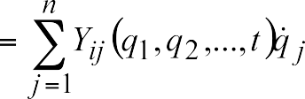
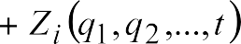

where the nxn matrix Y = [Yij] is non singular and Z is a nx1 vector.

23

Generalized Coordinates
q1 , q2 , q3 , q4 , q5
Generalized Speeds

Example 1

z

Aω^{C} = u1 b1 + u2 b2 + u3 b3
u₄ = derivative of q₄ u₅ = derivative of q₅
x q1
q₅
q₂

b₂

b3 C
C*
q₃ b1
P

y

q₄

Locus of the

point of contact Q on the plane A
24

Example 2

Bug moving radially on a turntable that can rotate (θ=0)
Generalized coordinates in A
- s, φ
- x1, x2
Generalized speeds

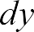
 or
Ω
Q
b s
2
θ
b1
φ
O
Generalized speeds and derivatives of generalized coordinates

a2 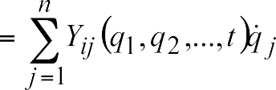
a1 Appears in
rheonomic constraints
25

Example 2: Turntable angular velocity is given

Bug moving radially on a rotating turntable (θ=0)
Generalized coordinates in A
- s
- x1
Generalized speeds

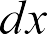
or

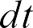

Generalized speeds and derivatives of generalized coordinates
Ω
Q
b s
2
θ
b1
φ
O

a2
a1 Appears in
rheonomic constraints
26

Nonholonomic Constraints are Written in Terms of Speeds

m constraints in n speeds

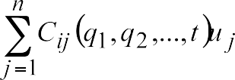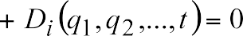

m speeds are written in terms of the n-m
- independent speeds
Define the number of degrees of freedom for a nonholonomic system in a reference frame A as p, the number of independent speeds that are required to completely specify the velocity of any particle belonging to the system, in the reference frame A.

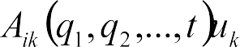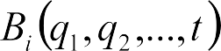

27

Number of degrees of freedom

Example 3

  - 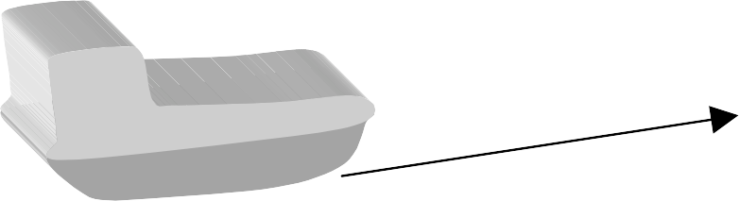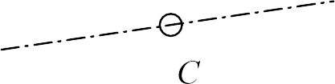n – m = 2 degrees of freedom

Generalized coordinates
  - (x1, x2, x3)

Speeds: Choice 1
  - forward velocity along the axis of the skate, vf
  - the speed of rotation about the vertical axis, ω
  - and the lateral (skid) velocity in the transverse direction, vl

Speeds: Choice 2

28

